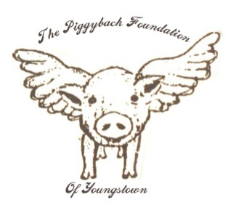
The Piggyback Foundation of Youngstown provides assistance to help maintain normalcy for a family experiencing serious illness. The Piggyback Foundation concentrates its efforts on meeting the needs of children.

Eligibility Requirements:
1. Applicant must provide a signed letter from their treating physician documenting the type of illness diagnosed, the treatment prescribed, and a statement that the applicant is currently undergoing treatment.
2. Recipients may receive assistance for a full calendar year (if warranted). If treatment extends beyond that time, the recipient must reapply in the month preceding the renewal date. To reapply, recipients need to submit a letter from their physician stating that treatment is still in progress and/or is starting again.
3. The below application must be submitted with aforementioned doctor’s note. A committee meets monthly and will vote on acceptance of new Piggyback recipients. Accepted families will be notified via phone call or email.
4. Financial status/need is not considered. Any family can apply to be adopted by the Piggyback Foundation.

Application Date:
Patient Information
Patient’s Name:
Birthday:
Patient’s Mailing Address:
Home Phone: Cell Phone:
Referring Physician/Source: Hospital/Organization:
Diagnosis: Date of Diagnosis:

Page 1 of 2
Family Information: Please pertinent information for all family members who permanently reside in the home:
Name Birthday Age Parent/Child/Other (circle one)
Name Birthday Age Parent/Child/Other (circle one)
Name Birthday Age Parent/Child/Other (circle one)
Name Birthday Age Parent/Child/Other (circle one)
Name Birthday Age Parent/Child/Other (circle one)
Program Interest: Please mark those programs below that interest you and your family. Please do not hesitate to include any and all services that can be useful! We are here to help!
Family Counts – Family togetherness activities such as dinners, movies, bowling, amusement parks, special occasions etc.
__ Dinner & Movie Night __Sporting Event tickets __Birthday/Graduation Parties
__Zoo/Museum Tickets __Family Meals @ Hospital __Holiday Parties
Education Counts –The emotional stress of illness can cause academic needs to falter. Piggyback can help with the following:
__Tutoring __Homework Help __School Supplies

Kids Count –Extracurriculars do not need to go by the wayside when dealing with a serious illness! Activities and fun are tremendous in helping lift kids’ spirits and build self-esteem. Please tell us how we can help with your child’s extra curricular activities:
__Renew for existing activities __Enroll in new activities __Provide necessary gear or clothing
Please list existing activities or interests: _________________________________________________________________________________________________________________________________________________________________________________________________________
Additional Information/Comments:
_________________________________________________________________________________________________________________________________________________________________________________________________________

Please mail completed application to:
Piggyback Foundation of Youngstown, PO Box 3184, Boardman Ohio 44513

